

**SWP391 – Software development project**

**ARTIX**

Version: 1.0

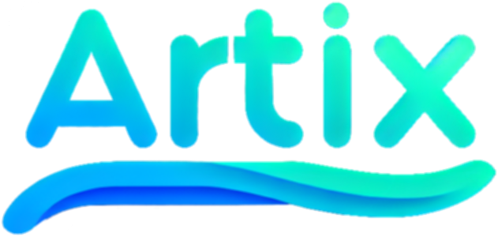

**ARTWORK SHARING PLATFORM**

– Ho Chi Minh, January 2024 –

|  |  |  |
| --- | --- | --- |
| **STT** | **Fullname** | **MSSV** |
| 1 | Nguyễn Dương Gia Bảo | SE171697 |
| 2 | Huỳnh Thiện Nhân | SE171117 |
| 3 | Trần Ánh Tuyết | SE170234 |
| 4 | Nguyễn Minh Thức | SE170592 |
| 5 | Phạm Minh Triều | SE172937 |

# III. User Manual

## ***1***. ***Overview***

## Artwork Sharing Platform, a vibrant online community where artists from around the globe come together to showcase their creativity, discover inspiration, and connect with art enthusiasts. Our platform serves as a dynamic hub for the exchange of diverse artistic expressions, fostering a supportive environment for both established and emerging talents.

## ***2. Workflow***

**2.1 If you be a Guess**

If you're a guest, you can only perform low-level functions like viewing photos, viewing artist, and changing background modes.

Higher is register a new Account.

**2.1.1 View image, artist**

If you want to view:

**First** way you just need to click a image or avatar of artist.

**Second** way is search name of artist or artwork you want to view

**2.1.2 Change background modes**

Step 1: Click on avatar icon

Step 2: Click on Light/Dark to change modes

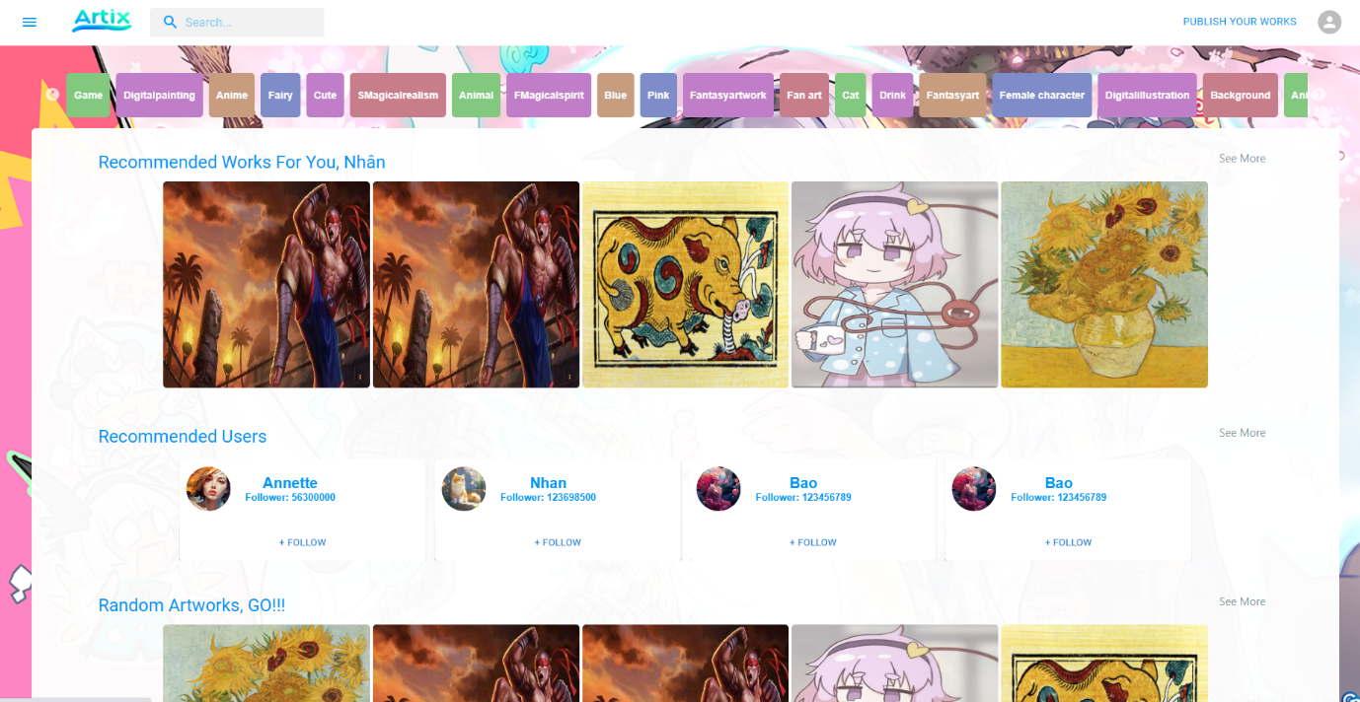

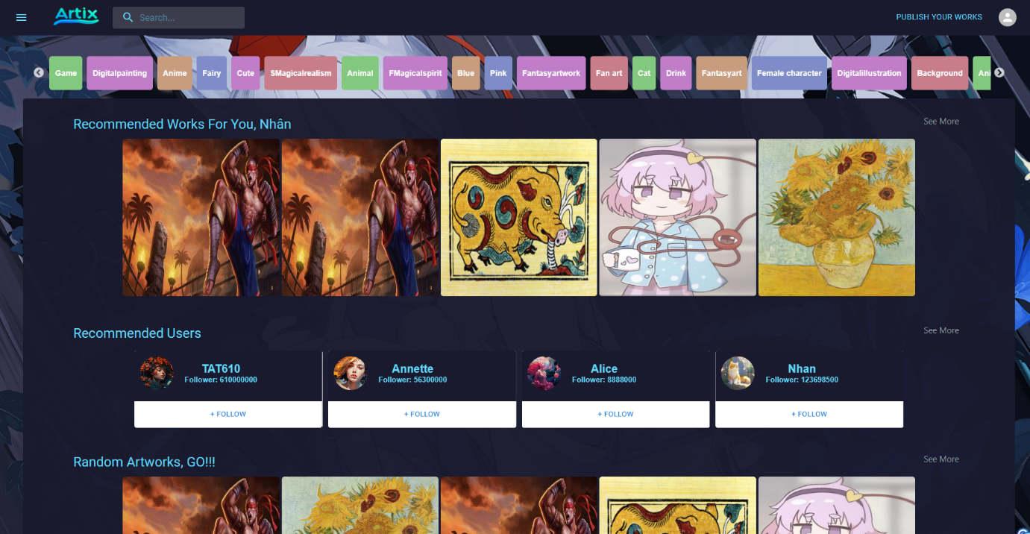

**2.1.3 Register Account**

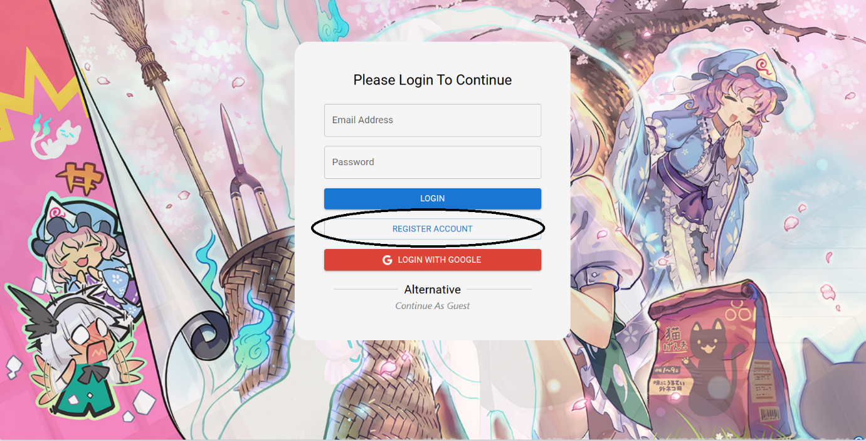

Step 1: Access to Website and click on Register button

Step2: Fill Infomation to Register Form

Step3: Submit the Form

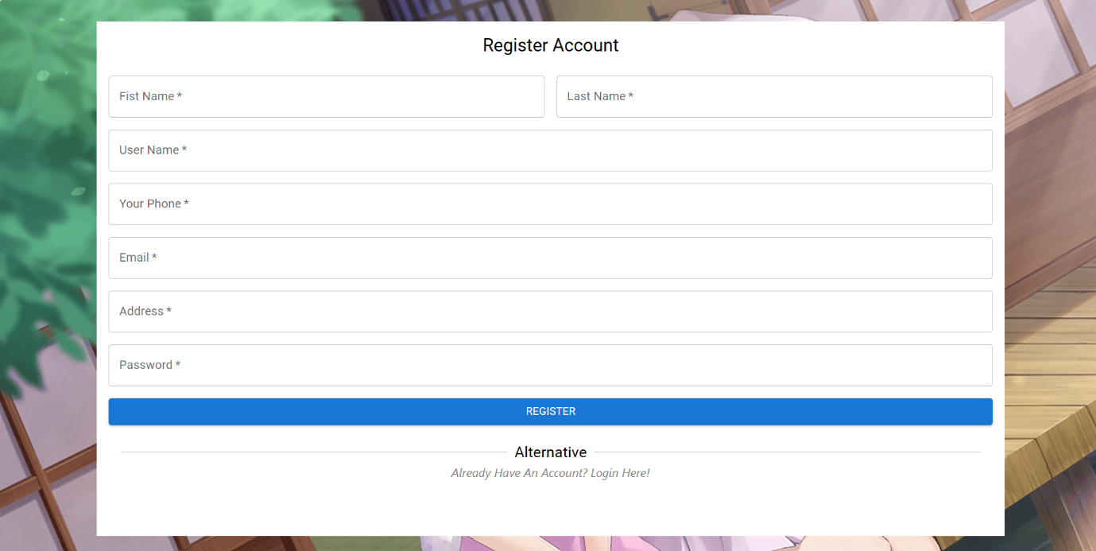

**2.2 If you be a User**

**2.2.1 Upload Image**

Step 1: Click “ Publish Your Works”

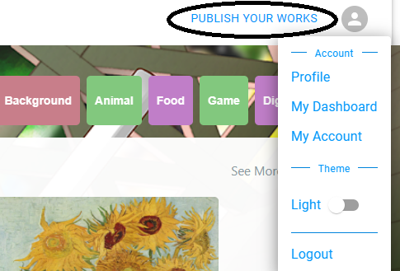

Step 2: Upload Image, Choose Tag, Is This Image Purchasable

Step 3: Click UpLoad Artwork

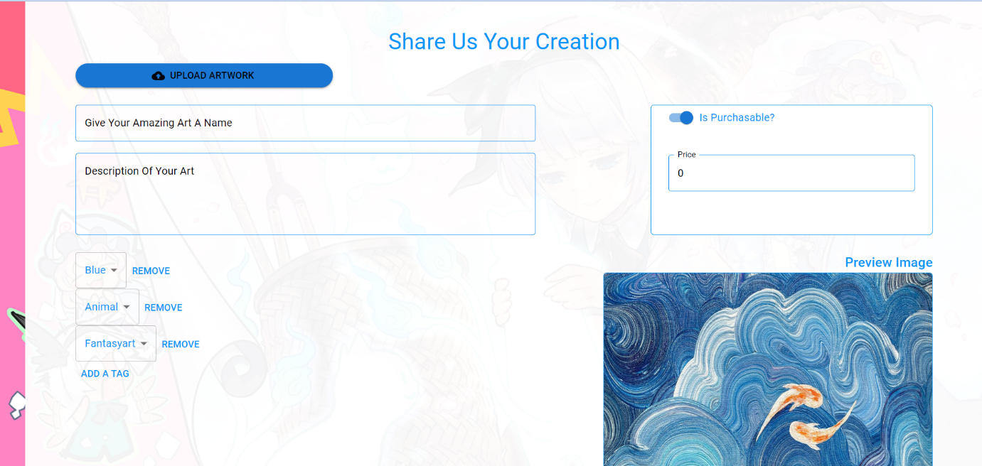

Step 4: If you want to see your Artwork, you click on your avatar and click “Profile”

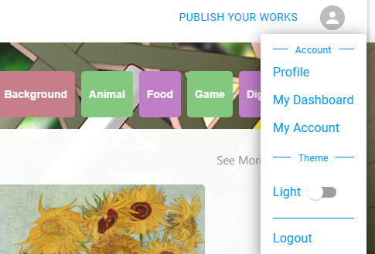

**2.2.2 How to give Commissions for Artist**